- We expect a majority of the Monetary Policy Committee to vote to keep Bank Rate at 5.25% at the March meeting. But sticky pay growth, a tight jobs market, and recent comments by MPC members point to another three-way split in the vote.
- Our main focus will be on whether the minutes indicate a May rate cut is in play. Unless the minutes are more dovish, the limited scope for data surprises mean the chances of a May move are fairly low in our view. We think June looks more likely for the first rate cut.
- Most MPC members who've spoken recently have said they need to feel more confident that inflation persistence has diminished. Data released since the February meeting is unlikely to have offered much help on that score. Pay growth, while slowing, remains elevated, and the jobs market still appears tight. Meanwhile, the Budget tax cuts will give a modest boost to demand.
In the press conference at the Monetary Policy Committee meeting in February, Bank of England governor Andrew Bailey said the key question was now how long Bank Rate would need to be kept at the current level before being cut. Data releases since then have not delivered a definitive answer to that question. Underlying price and wage pressures remain elevated, with recent movements broadly in line with the MPC's expectations (Chart 1). And though the economy was weaker in late 2023 than the BoE had anticipated, activity looks to have begun 2024 on a better footing, while the tax cuts announced in the recent Budget should add a little to demand.
So economic developments and comments by MPC members mean "not yet" is a view we think most of the committee will agree on. Consequently, we think the outcome of the next meeting (to be announced on March 21) will largely mimic February's, with the vote split three ways and the majority voting to keep the policy rate at 5.25%.
With a hold almost certain, the real focus will be on whether the minutes offer any hints about when that first rate cut will come. Assuming there's no sudden weakening in the data, for May to still be in play, we would expect the minutes to have a more dovish tone than in February.
Chart 1: Measures of inflation persistence have evolved largely in line with the MPC's expectations
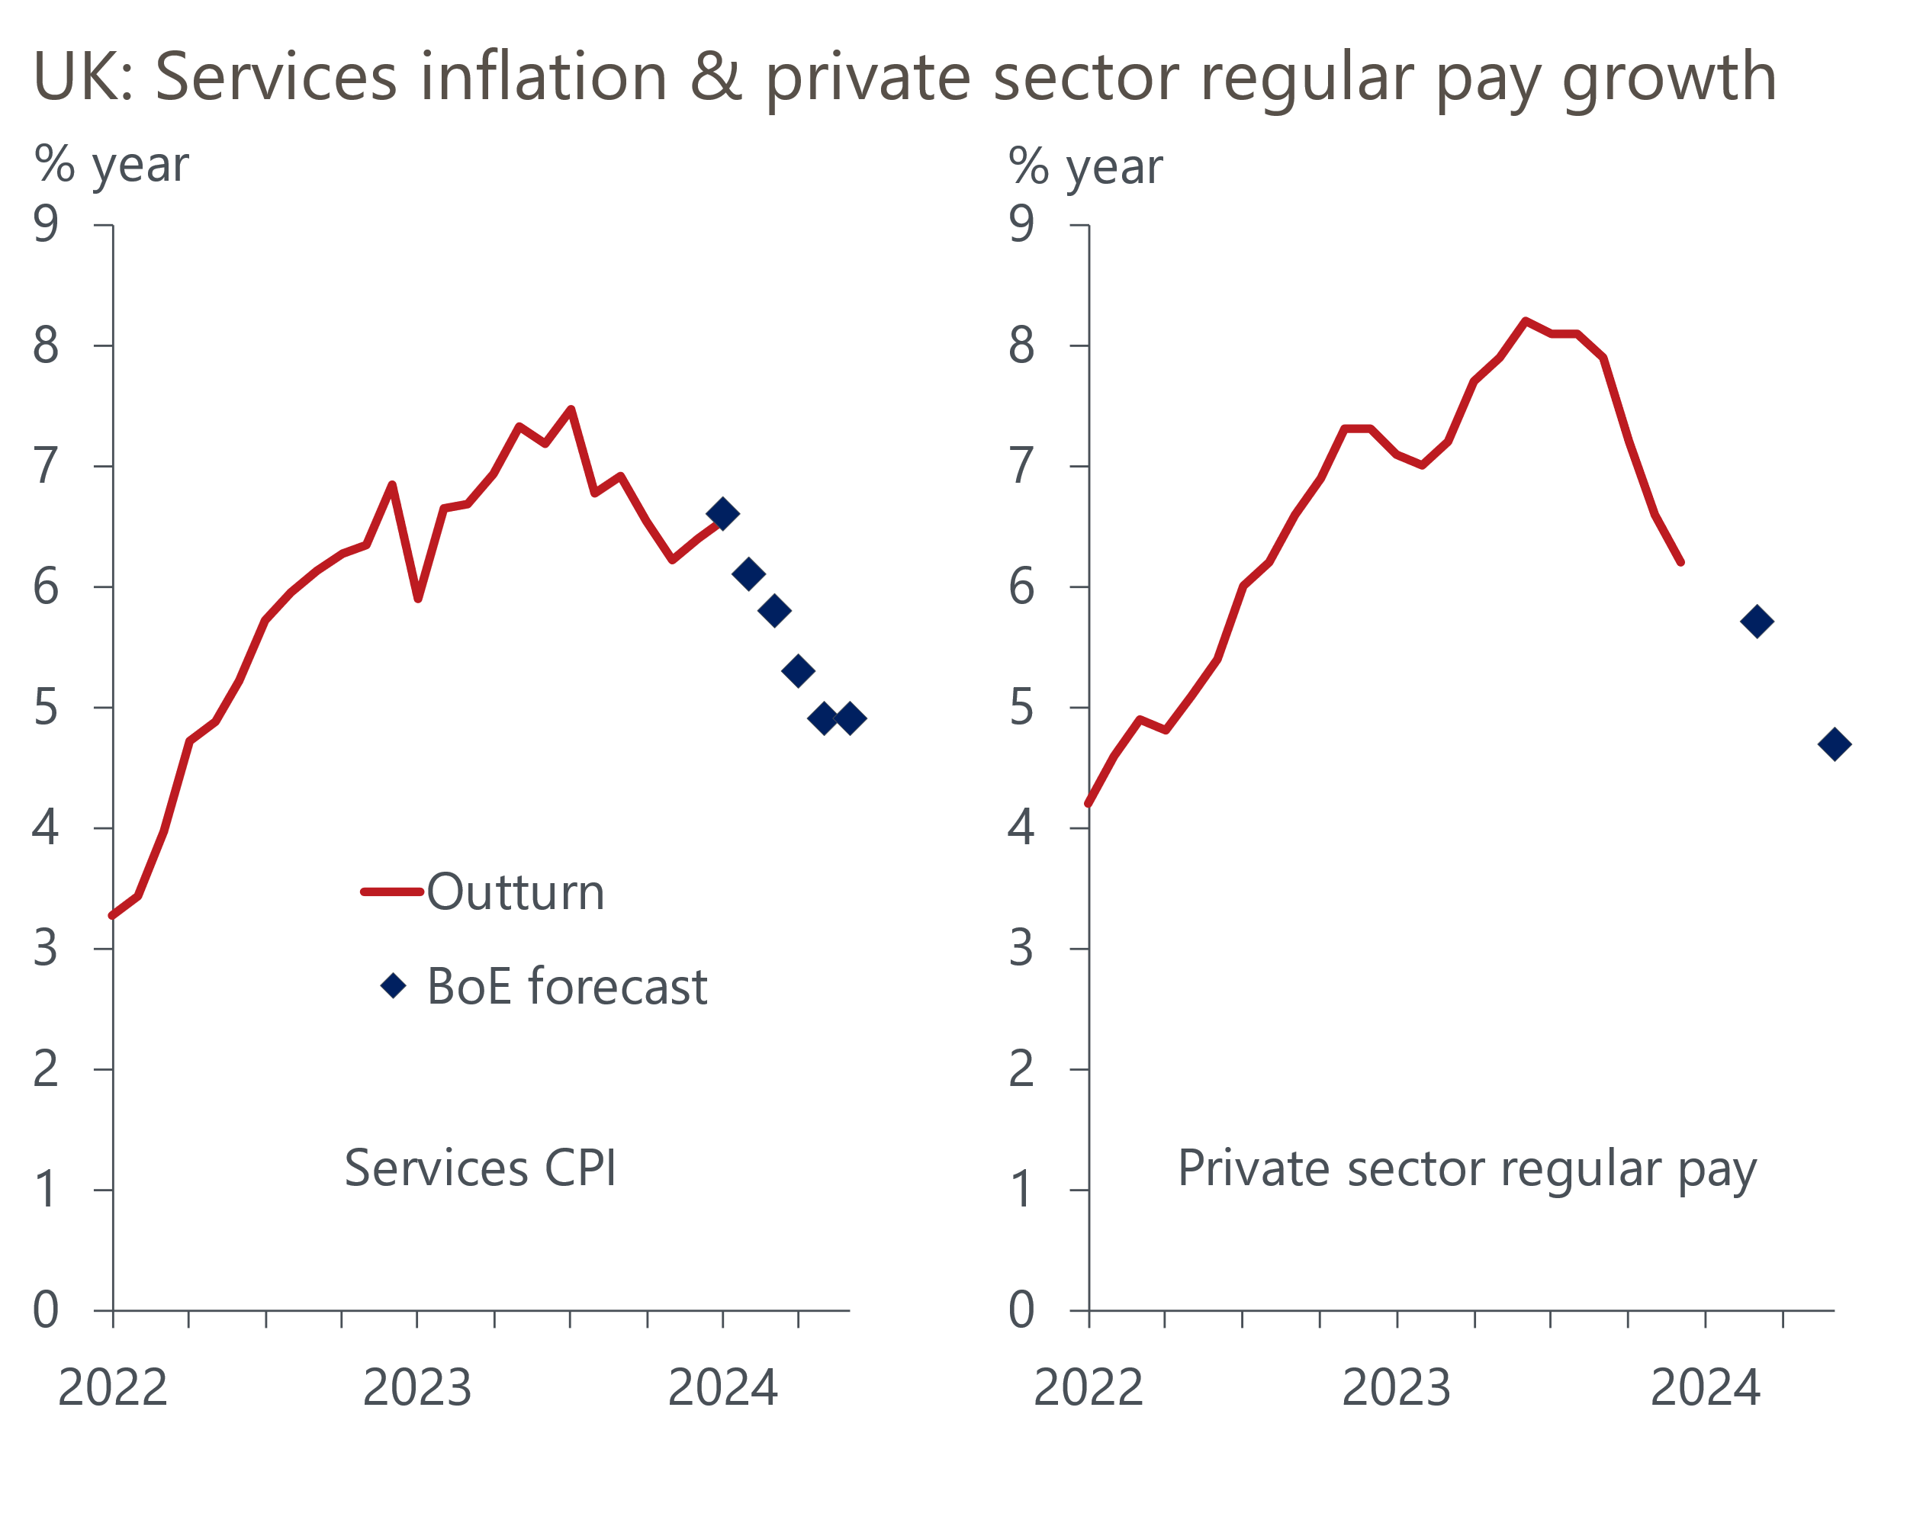
Sources: Haver Analytics, Bank of England Monetary Policy Report

Little meaningful news on the inflation front since February's meeting
Since the February meeting there's only been one inflation outturn, though the February data will be published the day before the March MPC announcement. CPI inflation was unchanged at 4% in January, just below the BoE's forecast of 4.1%. Services inflation was also 0.1ppts lower than the BoE anticipated. In both cases, this was largely due to the volatile air fares component – the category's weight more than doubled in January, amplifying the impact of the normal fall in prices between December and January. So it's unlikely that this release will have much impact on the MPC's views.
In February, the MPC had substantially downgraded its inflation forecast to take account of the plunge in gas prices in late-2023. With Ofgem confirming that the Energy Price Cap, which governs household energy bills, will be cut by 12% in April, the MPC's forecast that inflation will drop back to the 2% target in Q2 looks on track.

Private sector regular pay growth is proving sticky
The MPC has made clear that the outlook for core inflation is still its main focus. In this respect, recent developments around the tightness of the jobs market and the strength of private sector pay growth won't have done much to allay policymakers' concerns about risks to achieving sustainably low inflation.
On the pay front, headline (three-month average of the annual rate) private sector regular pay growth – the MPC's favoured measure of wage pressures – cooled to 6.1% in January. But this is still roughly double the pace that would be consistent with achieving the inflation target over the medium-term. Furthermore, our sentiment-based nowcast, developed in collaboration with Penta, suggests that pay growth is likely to remain at similar rates in the near-term (Chart 2). Meanwhile, according to the BoE's own Decision Maker Panel, pay growth expectations among Chief Financial Officers remained stuck around 5% in February, a similar pace to that reported since early 2023.
Chart 2: Our nowcast data suggests the downward momentum in pay growth has eased in early-2024
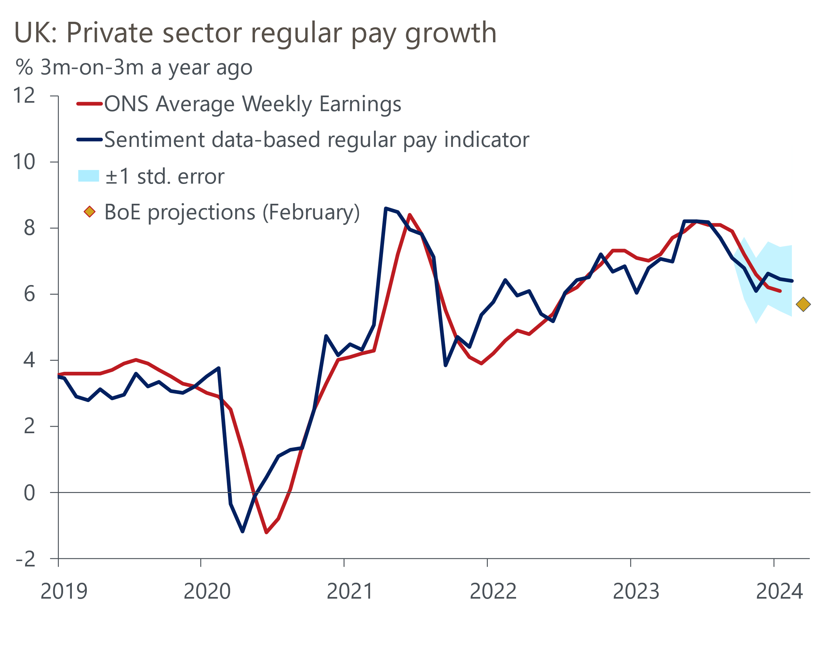
Sources: Oxford Economics, Haver Analytics, Penta
Overall, there's little in the recent data to suggest that pay growth is likely to undershoot the BoE's Q1 forecast of 5.7%. And given that the MPC has previously expressed concerns about the potential impact of a near-10% rise in the National Living Wage in April, we think the majority of the MPC will be keen to see more data on new year pay settlements before committing to rate cuts.
February's labour market release included data from the Labour Force Survey, reintroduced after a five-month hiatus. This incorporated the latest estimates of the size and composition of the UK population but didn't address the major issue of low survey response rates. Taking the new LFS data at face value, the labour market looks tighter than previously thought, with the unemployment rate much lower and economic inactivity significantly higher (Chart 3). But until the Transformed Labour Force Survey is available in September, we expect the MPC to place a relatively low weight on the LFS data and continue to emphasise the importance of studying a suite of indicators.
Chart 3: The latest labour market data showed the jobs market is tighter than thought
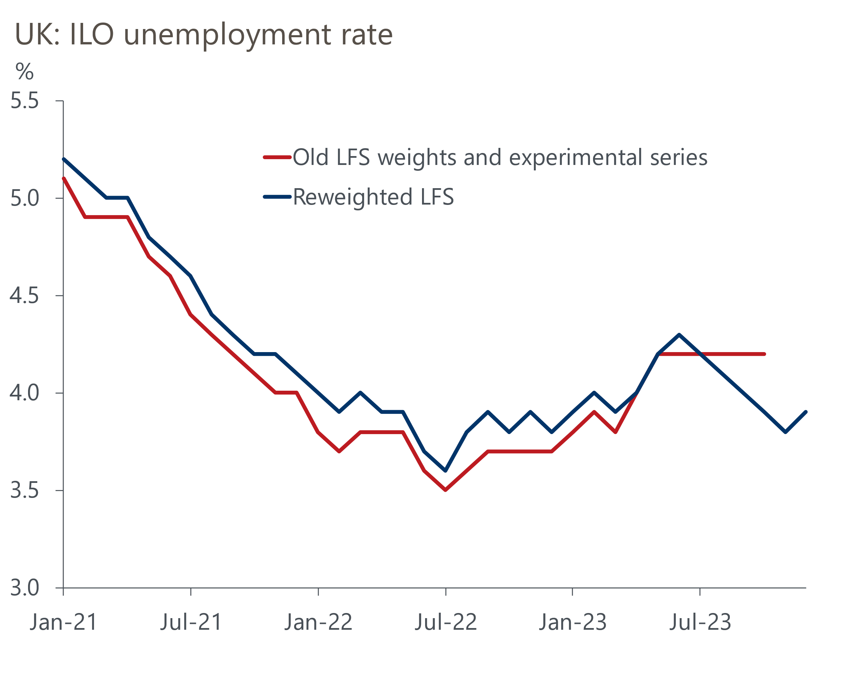
Sources: Oxford Economics, Haver Analytics

The economy is smaller than expected, but momentum has picked up
Although GDP growth has not featured highly in the MPC's decision making in recent years, the committee will be mindful of developments on that front, since it bears on the strength of inflationary pressures. Data and survey evidence released in the last few weeks have painted a gloomier picture of the end of last year, but a more positive one ahead. A 0.3% fall in GDP in Q4 was weaker than the flat performance expected by the BoE. Alongside a downward revision to growth earlier last year, this meant the economy ended 2023 0.4ppts smaller than the BoE had forecast.
However, it looks like Q4 2023 marked the low point for activity. A key factor underpinning December's weakness was a slump in retail sales. But retail sales volumes rose 3.4% m/m in January, making up all the ground lost in the previous month. This contributed to a 0.2% m/m rise in GDP in January. Furthermore, business survey data has strengthened in early-2024.
Still, as investors have pared back their expectations of how much rates will be cut this year, a tightening in financial conditions will weigh on the growth outlook versus expectations in February (Chart 4). There's already evidence that quoted mortgage rates are rising in response. And while a pick-up in mortgage approvals in January suggested housing market activity is recovering, net mortgage lending that month was unexpectedly weak.
Chart 4: Markets price between two and three 25bps rate cuts this year
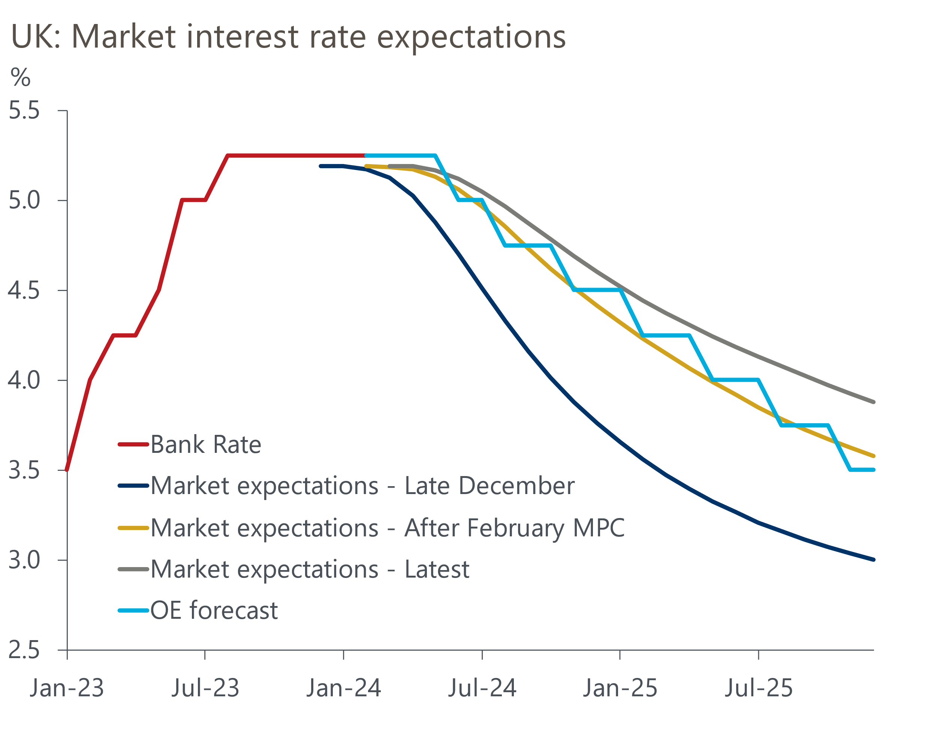
Sources: Oxford Economics, Haver Analytics

We expect another three-way vote split
Overall, we think the March meeting will deliver another three-way split, with the majority voting to keep Bank Rate at 5.25%. The only real uncertainty is whether Jonathan Haskel falls into line with the consensus, after voting for a rate hike in the last meeting (recent comments by MPC members are summarised in Table 1). In a recent interview with Reuters, he suggested the decision in February was "finely balanced" and that "if we accumulate more evidence on persistence….I'd be happy to change my vote." We're dubious he will have found that evidence the time of the next meeting.
Soon after February's meeting, Catherine Mann had said her vote for a hike was "not easy". But her subsequent comments were far more hawkish, and we expect Mann to vote again for a rate hike. At the other end of the spectrum, Swati Dhingra will almost certainly stick to her position of last month and vote for a cut.
But given the internal members have tended to vote as a bloc, we think the votes of the external will be of secondary importance. Of greater relevance will be any clues that the internals are close to voting for a rate cut. With only one more set of labour market and inflation data due out before the May meeting, the scope for data surprises to drive a change of view is limited.
So unless there's a change of language in the March minutes, the chances of a May cut look low. Given recent data and comments by BoE internals, such a change of tone seems unlikely. So we still think June looks the most likely timing of the first cut, with the risks skewed towards a later move.

Table 1: Key comments by MPC members
Speaker and link | Date | Key takeaway
Pill | 01-Mar | The BoE's chief economist intimated that he did not expect the MPC to cut rates soon, saying that "In my baseline scenario, the time for cutting Bank Rate remains some way off." This echoed Pill's view in February that the BoE would probably have to wait "several more months" before it could be sure that inflation pressures were no longer persistent.
Mann | 28-Feb | Mann argued that stickiness in services inflation was partly a consequence of “a lack of consumer discipline” in reining in businesses’ pricing power. In her view, better-off households were continuing to spend “disproportionately” on travel, eating out, and entertainment, despite higher mortgage costs. Mann's argument implies she's yet ready yet to fall in with the consensus, let alone support a rate cut.
Ramsden | 27-Feb | In a Q&A session following a speech on the BoE's role in bond markets, Ramsden said that inflation in services prices remained too high and that he wanted more evidence that it was easing before considering a cut in rates.
Bailey | 20-Feb | Speaking before the Treasury Select Committee, the BoE governor said "we don't need obviously inflation to come back to target before we cut interest rates". Taken literally, Bailey's comments suggest a March cut is in play. But context is important, and Bailey was pushing back against concerns from some MPs that the MPC would be behind the curve in loosening policy.
Greene | 15-Feb | Citing persistence in wage and services prices pressures, Greene said that she would "need to see further evidence that inflation persistence is less embedded than previously feared before I would consider voting to loosen policy."
Haskel | 09-Feb | While welcoming the recent fall in inflation, Haskel, one of the two MPC members who voted for a rate hike in January, said he was still studying the data for signs that it is no longer necessary for rates to rise further. While his January decision had been "finely balanced", Haskel wanted "to wait a bit longer to accumulate more evidence on…persistence."
Breeden | 07-Feb | The BoE deputy governor said she had "become less concerned that rates might need to be tightened further" and that her focus "has shifted to thinking about how long rates need to remain at their current level.”
Dhingra | 06-Feb | Dhingra elaborated on her reasons for voting for a cut in Bank Rate in February's meeting, citing lags in the effect of past rate hike coming through, the outlook for deflation in goods prices and the risk that policy has been overtightened to the detriment of the economy.
Source: Oxford Economics/Various

